[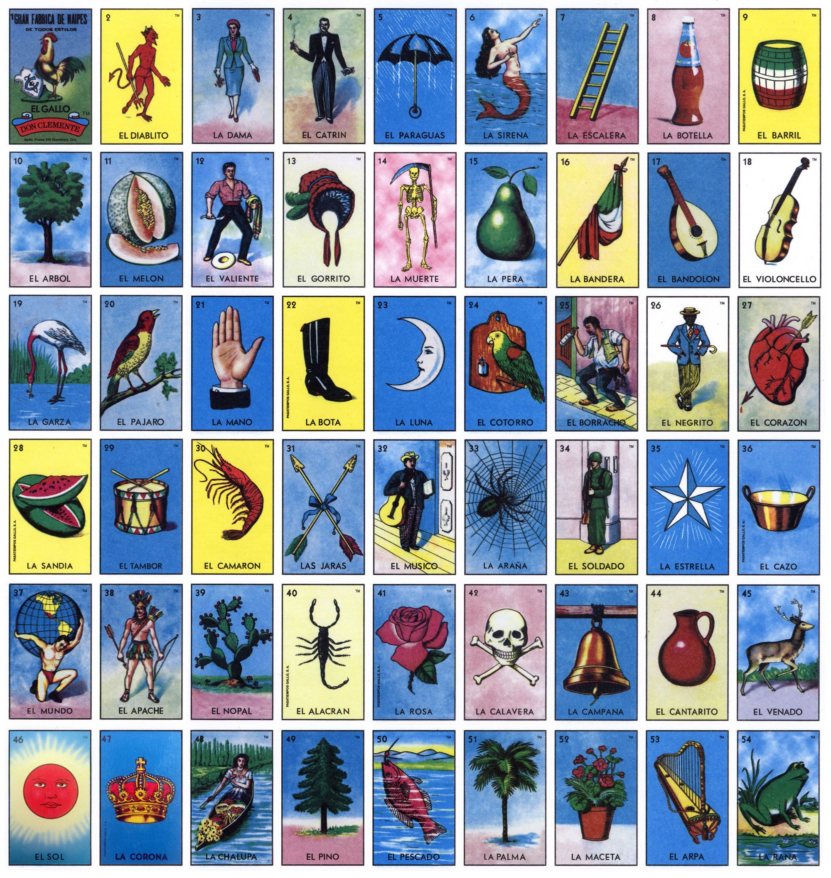](https://www.google.com/url?sa=i&url=https%3A%2F%2Fwww.pinterest.com%2Fpin%2F102527328998307926%2F&psig=AOvVaw3mj9bKYEo_oNbC2RHLhIDE&ust=1587842833846000&source=images&cd=vfe&ved=0CAIQjRxqFwoTCMD-4eDlgekCFQAAAAAdAAAAABAG)